--QUERY
SET STATISTICS IO ON
SELECT SUM(dbo.SEF_PrestacaoContrato(contr_emprst_fss.num_sqncl_cempf, contr_emprst_fss.dat_credto_htvrb, contr_emprst_fss.qtd_pacrst_cempf, contr_emprst_fss.cod_tpepf, contr_emprst_fss.vlr_slddv_cempf)) FROM CONTR_EMPRST_FSS WHERE contr_emprst_fss.num_sqncl_cempf in ( SELECT DISTINCT aval_contr_fss.num_sqncl_cempf FROM AVAL_CONTR_FSS, CONTR_EMPRST_FSS WHERE aval_contr_fss.num_idntf_dpdte = 0 AND contr_emprst_fss.cod_situa_cempf = 'A' AND contr_emprst_fss.num_sqncl_cempf = aval_contr_fss.num_sqncl_cempf )
SET STATISTICS IO OFF

-- IO STATISTIC
--Table 'aval_contr_fss'. Scan count 1, logical reads 73

--EXECUTION PLAN

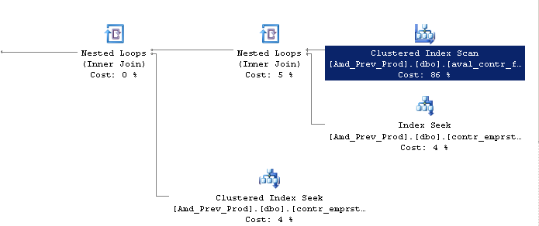

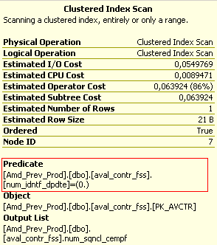

--Column’s Selectvily

SELECT 1.0/(COUNT(DISTINCT(num_idntf_dpdte))) FROM aval_contr_fss
--0.010204081632

--OR

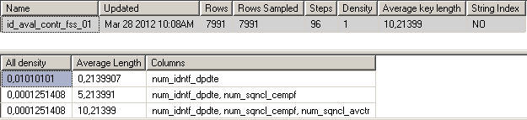

--CREATING THE NEW INDEX

CREATE NONCLUSTERED INDEX id_aval_contr_fss_01 on aval_contr_fss(num_idntf_dpdte)

-- IO STATISTIC
--Table 'aval_contr_fss'. Scan count 1, logical reads 2

--EXECUTION PLAN

